DEPARTMENT OF COMPUTER ENGINEERING

BE RESULT ANALYSIS SEM V (2018-19)

TOPPER IN OVERALL:

SR.NO. | NAME OF THE TOPPER STUDENTS | CGPI
1. | KOLEKAR AAKASH ANIL SAVITA | 9.56
2. | DUDHAL SHWETA RAJU USHA | 9.41
3. | ATKARI ADITYA CHANDRAKANT SHARMILA | 9.41

TOPPER IN SUBJECT:

SUBJECTS | NO. | NAME OF THE STUDENT | MARKS (100)
UP | 1. | KOLEKAR AAKASH ANIL SAVITA | 87
UP | 2. | SONPAROTE DEEPANSHU RAJKUMAR SADHANA | 85
DBMS | 1. | BHOIR ABHISHEK ARJUN AMITA | 82
DBMS | 2. | DESAI SALONI NITIN ANJALI | 80
CN | 1. | PASI PIYUSH SINGH UMESH CHANDRA JWALAMUKHI | 80
CN | 2. | ATKARI ADITYA CHANDRAKANT SHARMILA | 78
TCS | 1. | ANGNE HEMALI KISHORE KAUMUDI | 87
TCS | 2. | GORE BHAVEN VIKAS BHAVIKA | 79
Multimedia | 1 | KONGARA POORNACHANDRAPRASAD RAGHU SUJATHA | 82
Multimedia | 2 | PATHAN TALIF ANDALIB NAWSHEEN | 82
AA | 1 | PANDA DEEPALI SURJA MINNOTI | 92
AA | 2 | PASI PIYUSH SINGH UMESH CHANDRA JWALAMUKHI | 91

RESULT SUMMARY:

OVERALL RESULT: - 96 %

NAME OF THE SUBJECT | NAME OF SUBJECT TEACHER | TOTAL NO. OF STUDENTS APPEARED | TOTAL NO. OF STUDENTS PASSED | PASS PERCENTAGE IN EACH SUBJECT | CANDIATES GETTING
 |  |  |  |  | 40 – 50 MARKS | 51 – 59 MARKS | 60 & ABOVE  60 MARKS
MICROPROCESSOR | PROF.D.P.KAPSE | 147 | 120 | 81.6% | 39 | 23 | 57
DBMS | PROF.ANITA LAHANE  PROF.D.DHANGAR | 147 | 146 | 99.3% | 13 | 24 | 105
CN | PROF.S.P.KHACHNE  PROF.B.M.PATIL | 147 | 136 | 92.5% | 32 | 31 | 66
TCS | PROF.SUMITRA SADHUKHAN  PROF.NAINA KAUSHIK | 147 | 129 | 87.7% | 34 | 39 | 58
MULTIMEDIA | PROF.BHAVESH PANCHAL | 86 | 73 | 84.8% | 21 | 18 | 26
ADVANCED ALGORITHM | PROF.PRIYA PARATE | 61 | 61 | 100% | 1 | 3 | 56

STATISTICAL ANALYSIS:-

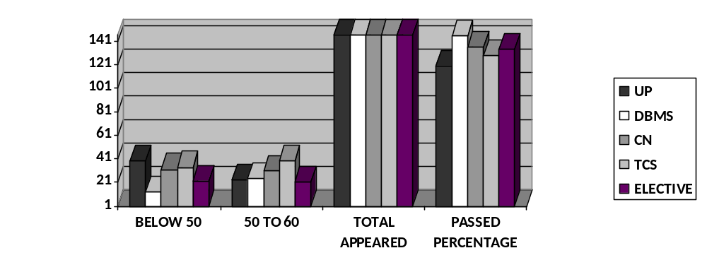

Fig1. : Subject wise Statistics

CGPI STATISTICS:-

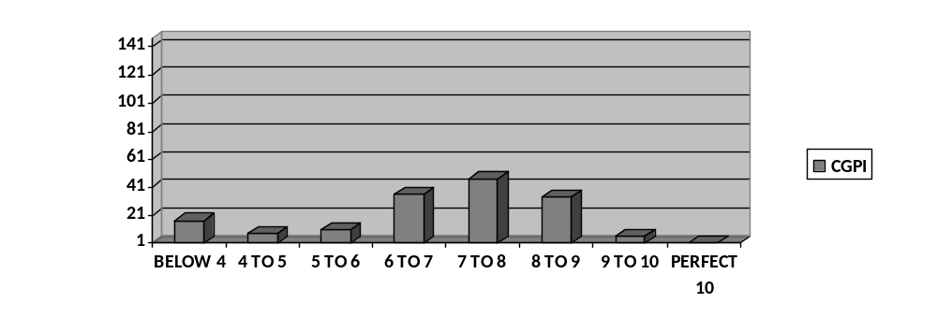
Fig2. : Overall CGPI Statistics

